Literary Resources Library Guide

Accessing NoodleTools - an online research management platform.

- Login to your Gmail Account
- Click the waffle (Square of squares) in the upper right hand corner
- Click More
- Click NoodleTools
- Create new user (student)
- Fill in graduation year

Accessing the Library Website:

- Go to olsh.org
- Click on the Academics tab
- Click The Tisch Family Library
- Click Mrs.Cvitkovic’s OLSH Library Website

Ask Here PA - Librarians from around PA that assist in answering questions 24/7.

- Go to Library Website
- Scroll over the Research tab listed on the left side of the page.
- Click Ask Here PA
- Fill out information on right side of screen and hit connect!

Artemis Literary Sources – bios, works, criticisms, other articles about author/works

- Go to Library Website
- Scroll over the Research tab listed on the left side of the page.
- Click Literary Criticism Resources
- Click Artemis Literary Sources

Bloom’s Literature – bios, works, criticisms, other articles about author/works

- Go to Library Website
- Scroll over the Research tab listed on the left side of the page.
- Click Literary Criticism Resources
- Click Bloom’s Literature
- Username: olsh Password: chargers

CLP Databases –

- Go to Library Website
- Scroll over the Research tab listed on the left side of the page.
- Click CLP Databases
- Click Find or type one of the databases below in keyword
- 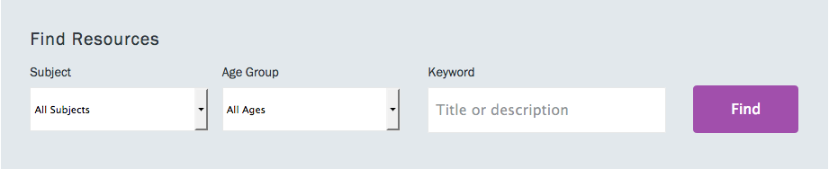
- Academic Search Main Edition culture articles
- Biography in Context - bios, works, other articles about author/works
- Contemporary Authors – bios, works, criticisms, other articles about author/works
- Explora: Public Libraries - culture articles, bios, criticisms, general articles about author/works
- Literature Resource Center – bios, works, criticisms, other articles about author/works
- NoveList – bios, works

